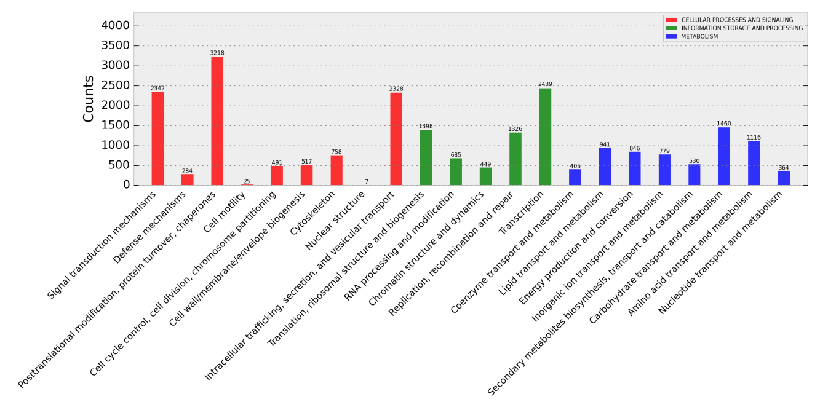
Supplementary Fig. 1 EggNOG classification of assembled unigenes. 22,708 matched unigenes were classified into three main categories: cellular processes and signaling, information storage and processing, metabolism.

